Binah Ndeh

Home Work 1

1. Define the following;

**a. Operating System**

The main software that runs on a computer system

**b. Computer Software**

The intangible part of the computer

**c. Computer Hardware**

The tangible part of the computer

**d. UNIX**

A group of operating systems with a similar kernel

**e. UNIX Kernel**

It is the core of the UNIX operating system

**f. LINUX**

It is a UNIX - type operating system created by Linus and open to the public

**g. LAN**

Stands for Local Area Network and spans in a relatively small are

**h. Network**

It is the communication between two or more operating systems.

**2. List some of the flavors of UNIX and LINUX. What Flavors will you learn in this course? What other Operating Systems will you learn in this program?**

Flavors of UNIX and LINUX ; Solaris, AIX, IRIX, HP-OX, MacOS, Centos, RHEL

RHEL, Solaris and Centos

Will learn Windows + DevOPS + Vmware Operating systems

**b. What Categories of Hypervisors will be working with in this course?**

Will be working with Hosted hypervisors e.g Oracle VirtualBox and bare-metal hypervisors e.g Vmware Esxi

**3. What branch of IT will you be specialized in?**

System Administrator

**4. Who are the founding Fathers of UNIX?**

Ken Thompson and Dennis Ritchie

5. Watch the slide Presentation of the "First Computer" attached to this homework and answer the following question;

**a. Where and when was the first computer built?**

In the 1946, the first ENIAC was built for the United States Military.

**b. What were the specifications for the first computer?**

System specifications include: Memory, hard drive,CPU and operating system

**6. What is the difference between computer memory and storage**

Computer memory is the size of the RAM where software is loaded e.g my RAM size is 8.00GB while the hard drive storage space is the available capacity used to store data.

**7. Display the specs of your system.**

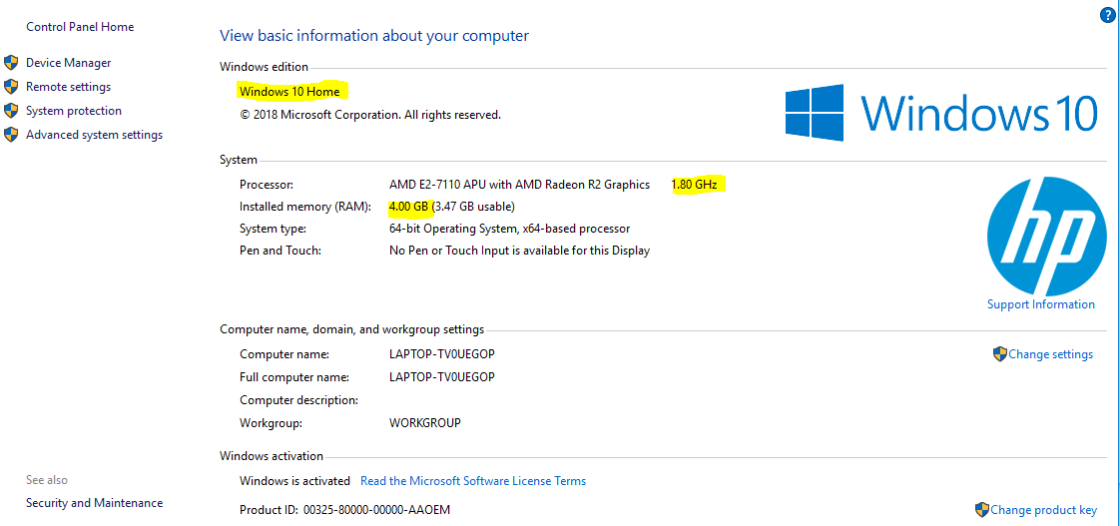

OS, RAM and CPU specifications are highlighted

For hard drive storage, total space is 450GB

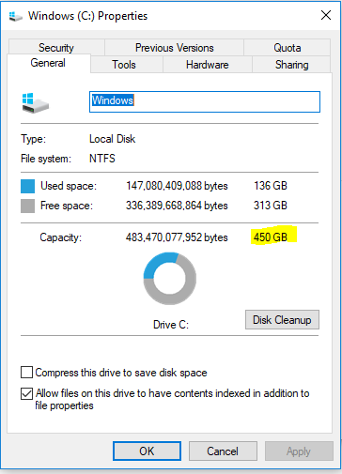

**8. Watch the following video and install Microsoft word 2007 on your system if you need it. Click on the following link to download the software.**

MS Word successfully downloaded. Thank you for sharing!